#include <stdio.h>
#include <limits.h>

#define MAX_PROCESSES 100

int main() {
int n;
int Process_ID[MAX_PROCESSES];
int Arrival_Time[MAX_PROCESSES];
int Burst_Time[MAX_PROCESSES];
int Priority[MAX_PROCESSES];
int Completed[MAX_PROCESSES];
int Completion_Time[MAX_PROCESSES];
int Turnaround_Time[MAX_PROCESSES];
int Waiting_Time[MAX_PROCESSES];

int Current_Time = 0;
int Completed_Count = 0;
int i, Selected_Process;
int Highest_Priority;

// Input number of processes
printf("Enter number of processes: ");
scanf("%d", &n);

// Input process details
for (i = 0; i < n; i++) {
printf("Enter Process ID[%d]: ", i+1);
scanf("%d", &Process_ID[i]);
printf("Enter Arrival Time[%d]: ", i+1);
scanf("%d", &Arrival_Time[i]);
printf("Enter Burst Time[%d]: ", i+1);
scanf("%d", &Burst_Time[i]);
printf("Enter Priority[%d] (lower number = higher priority): ", i+1);
scanf("%d", &Priority[i]);
Completed[i] = 0; // false
}

// Priority Scheduling Algorithm
while (Completed_Count < n) {
Highest_Priority = INT_MAX;
Selected_Process = -1;

// Find highest priority process that has arrived
for (i = 0; i < n; i++) {
if (Arrival_Time[i] <= Current_Time && Completed[i] == 0) {
if (Priority[i] < Highest_Priority) {
Highest_Priority = Priority[i];
Selected_Process = i;
}
}
}

if (Selected_Process == -1) {
// No process available, increment time
Current_Time++;
} else {
// Execute selected process
int Start_Time = Current_Time;
Completion_Time[Selected_Process] = Start_Time + Burst_Time[Selected_Process];

Turnaround_Time[Selected_Process] =
Completion_Time[Selected_Process] - Arrival_Time[Selected_Process];

Waiting_Time[Selected_Process] =
Turnaround_Time[Selected_Process] - Burst_Time[Selected_Process];

Current_Time = Completion_Time[Selected_Process];
Completed[Selected_Process] = 1; // true
Completed_Count++;
}
}

// Display results
printf("\nProcess Scheduling Results:\n");
printf("PID\tArrTime\tBurst\tPriority\tWait\tTurnaround\n");
printf("---\t------\t-----\t--------\t----\t---------\n");

for (i = 0; i < n; i++) {
printf("%d\t%d\t%d\t%d\t\t%d\t%d\n",
Process_ID[i], Arrival_Time[i], Burst_Time[i],
Priority[i], Waiting_Time[i], Turnaround_Time[i]);
}

// Calculate and display averages
float avg_wait = 0, avg_turn = 0;
for (i = 0; i < n; i++) {
avg_wait += Waiting_Time[i];
avg_turn += Turnaround_Time[i];
}
printf("\nAverage Waiting Time: %.2f\n", avg_wait / n);
printf("Average Turnaround Time: %.2f\n", avg_turn / n);

return 0;
}

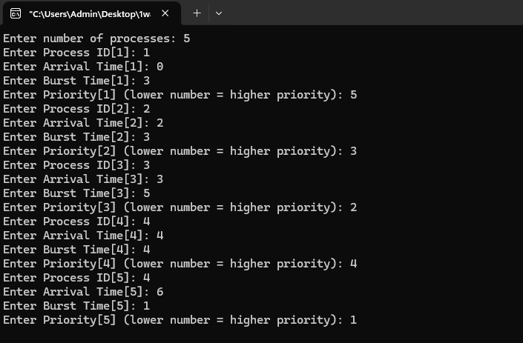

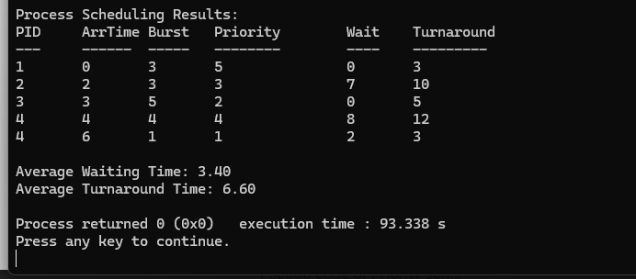

2)
#include <stdio.h>
#include <limits.h>

#define MAX 100

int main() {
int n;
int pid[MAX], at[MAX], bt[MAX], prio[MAX];
int rt[MAX]; // Remaining time
int ct[MAX], tat[MAX], wt[MAX];
int current_time = 0;
int completed = 0;
int i;

printf("Enter number of processes: ");
scanf("%d", &n);

// Input
for (i = 0; i < n; i++) {
printf("Enter Process ID, Arrival Time, Burst Time, Priority for process %d: ", i + 1);
scanf("%d %d %d %d", &pid[i], &at[i], &bt[i], &prio[i]);
rt[i] = bt[i]; // Remaining_Time[i] = Burst_Time[i]
}

// Preemptive Priority Scheduling
while (completed < n) {
int highest_priority = INT_MAX; // large_number equivalent
int selected = -1;

// Select process with highest priority among arrived processes
for (i = 0; i < n; i++) {
if (at[i] <= current_time && rt[i] > 0) {
if (prio[i] < highest_priority) {
highest_priority = prio[i];
selected = i;
}
}
}

if (selected == -1) {
// No process available at this time
current_time++;
} else {
// Execute selected process for 1 unit (preemption possible each unit)
rt[selected]--;
current_time++;

// If process finished
if (rt[selected] == 0) {
ct[selected] = current_time;
tat[selected] = ct[selected] - at[selected];
wt[selected] = tat[selected] - bt[selected];
completed++;
}
}
}

// Output
printf("\nPID\tAT\tBT\tPR\tCT\tTAT\tWT\n");
printf("----\t--\t--\t--\t--\t---\t--\n");
float avg_wt = 0, avg_tat = 0;
for (i = 0; i < n; i++) {
printf("%d\t%d\t%d\t%d\t%d\t%d\t%d\n",
pid[i], at[i], bt[i], prio[i], ct[i], tat[i], wt[i]);
avg_wt += wt[i];
avg_tat += tat[i];
}

printf("\nAverage Waiting Time: %.2f\n", avg_wt / n);
printf("Average Turnaround Time: %.2f\n", avg_tat / n);

return 0;
}
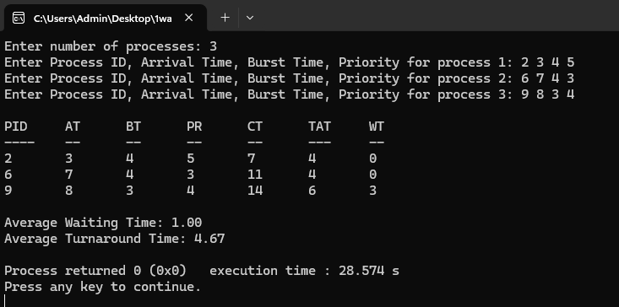

3)
#include <stdio.h>

#define MAX 100

int main() {
int n, tq;
int pid[MAX], at[MAX], bt[MAX], rt[MAX];
int wt[MAX] = {0}, tat[MAX] = {0};
int completed = 0;
int current_time = 0;

// Simple circular queue for ready queue (store indices of processes)
int rq[MAX];
int front = 0, rear = 0; // queue is empty when front == rear

printf("Enter number of processes: ");
scanf("%d", &n);

printf("Enter time quantum: ");
scanf("%d", &tq);

for (int i = 0; i < n; i++) {
printf("Enter PID, Arrival Time, Burst Time for process %d: ", i + 1);
scanf("%d %d %d", &pid[i], &at[i], &bt[i]);
rt[i] = bt[i]; // remaining_time[i] = burst_time[i]
}

// Function-like macro to check if queue is empty
#define QUEUE_EMPTY (front == rear)

// Add newly arrived processes into ready_queue
auto void add_new_arrivals() {
for (int i = 0; i < n; i++) {
// process not yet completed and has arrived
if (at[i] <= current_time && rt[i] > 0) {
// check if already in queue (simple scan)
int in_queue = 0;
for (int j = front; j != rear; j = (j + 1) % MAX) {
if (rq[j] == i) {
in_queue = 1;
break;
}
}
if (!in_queue) {
rq[rear] = i;
rear = (rear + 1) % MAX;
}
}
}
}

// Main Round Robin loop
while (completed < n) {
// Add all processes that have arrived up to current_time
add_new_arrivals();

if (QUEUE_EMPTY) {
// CPU idle, move time forward
current_time++;
continue;
}

// Dequeue from front
int idx = rq[front];
front = (front + 1) % MAX;

// Execute process for min(remaining_time, time_quantum)
int exec_time = (rt[idx] > tq) ? tq : rt[idx];
rt[idx] -= exec_time;
current_time += exec_time;

// After execution, add newly arrived processes
add_new_arrivals();

if (rt[idx] > 0) {
// not finished, put back into end of queue
rq[rear] = idx;
rear = (rear + 1) % MAX;
} else {
// finished
tat[idx] = current_time - at[idx];
wt[idx] = tat[idx] - bt[idx];
if (wt[idx] < 0) wt[idx] = 0; // safety
completed++;
}
}

// Output
printf("\nPID\tAT\tBT\tWT\tTAT\n");
printf("----\t--\t--\t--\t---\n");
float avg_wt = 0, avg_tat = 0;
for (int i = 0; i < n; i++) {
printf("%d\t%d\t%d\t%d\t%d\n",
pid[i], at[i], bt[i], wt[i], tat[i]);
avg_wt += wt[i];
avg_tat += tat[i];
}

printf("\nAverage Waiting Time: %.2f\n", avg_wt / n);
printf("Average Turnaround Time: %.2f\n", avg_tat / n);

return 0;
}

